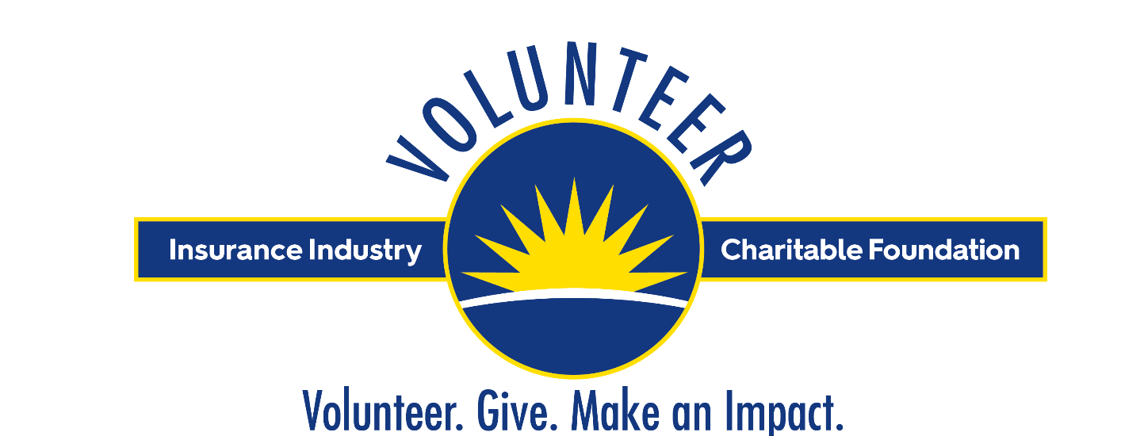

October 14 – 21, 2023

The Insurance Industry Charitable Foundation is proud to host its annual Week of Giving on October 14-21, the industry’s longest ongoing volunteer initiative, as we celebrate another year of industry volunteerism and giving back to our communities.

The Week of Giving is an eight-day international and industry-wide volunteer initiative during which IICF brings together insurance industry professionals to complete volunteer projects and service that benefit community nonprofits throughout the United States and United Kingdom. Since 1998, Week of Giving volunteers have contributed more than 320,000 hours of service to nonprofits and charitable organizations.

IICF invites you and your organization to join us in the Week of Giving
Be a Part of Something Greater!

Below you’ll find details about the Insurance Industry Charitable Foundation and IICF Week of Giving.

Also provided below are template email communications and social media messaging for your use in informing and exciting your employees and team members about this important industry initiative. We hope you find these sample messages helpful as well as you share photos and updates of your volunteerism in action during the Week of Giving.

Once again, IICF looks forward to working with your organization to make the IICF Week of Giving a tremendous success as the industry unites in helping communities and enriching lives, together!

IICF Week of Giving: Volunteer. Give. Make an Impact.

Volunteer
We invite you to engage your organization in volunteering and join us during the IICF Week of Giving. To register a volunteer team or register as an individual volunteer, and sign up for volunteer projects, please visit weekofgiving.iicf.org and follow these steps:

- Designate a “Team Leader” who will serve as a liaison between your organization, IICF and the local nonprofit where your team will volunteer by clicking Register Team Leader.
Please note: Those registering as individual volunteers will register as their own team leader.

- Select a volunteer project at and register your team by clicking on Search Projects

- Following registration, the Team Leader will receive a packet of information from IICF containing recruitment materials and other helpful information.

- To show your Week of Giving spirit and display your industry pride, we have created a downloadable “Volunteer” design that you may use when ordering t-shirts for your company. We encourage volunteers to wear their company logo along with the IICF Volunteer image proudly when helping in the community. The downloadable t-shirt design can be found here.

- Be sure to take lots of photos of your team in Week of Giving shirts when volunteering – and send to IICF!

For additional volunteering information and resources, please see our Volunteer Resource page and Week of Giving FAQs

Make an Impact

Through the collective strength of IICF supporters volunteering and giving together, we can make a much more significant impact in our communities. IICF’s commitment to year-round volunteering allows us to make an even greater impact in the lives of individuals and families in need. Be a Part of Something Greater!

IICF Week of Giving Communications Materials

General IICF Information:

About the Insurance Industry Charitable Foundation (IICF)

The Insurance Industry Charitable Foundation (IICF) is a unique nonprofit that unites the collective strengths of the insurance industry to help communities and enrich lives through grants, volunteer service and leadership. Established in 1994, IICF has served as the philanthropic voice and foundation of the insurance industry for close to thirty years, contributing $45 million in community grants along with over 320,000 volunteer hours by more than 115,000 industry professionals. IICF reinvests locally where funds are raised, serving hundreds of charities and nonprofit organizations, for maximum community impact.

IICF is a registered nonprofit organization under section 501(c)(3) of the IRS code. Learn more at www.iicf.org or follow us on social media: Insurance Industry Charitable Foundation on LinkedIn and @doubleicf on Instagram and Twitter

IICF Week of Giving Communications Templates and
Social Media Messaging:

We hope that you find the templates provided below to be useful as you inform and excite your organization about the IICF Week of Giving and as you recruit your company volunteers.

Please tailor these messages to meet your specific needs, and IICF is pleased to work with your organization in shaping specific communications that may be helpful.

Template email #1 - Volunteer Recruitment

Date: [Date Distributed]
To: [All Employees]
From: [Executive’s Name & Title / Team Leader’s Name & Title]
Re: Insurance Industry Charitable Foundation’s Week of Giving 2023

Join [Company Name] in supporting the community and Be a Part of Something Greater!

IICF Week of Giving
October 14-21, 2023

[Company] is proud to announce our support of the Insurance Industry Charitable Foundation’s 2023 Week of Giving.

The IICF Week of Giving empowers the insurance industry to take a leadership role in the community through a dedicated week of volunteer projects throughout the United States and United Kingdom. This weeklong, international and industry-wide initiative brings together thousands of insurance professionals each year to complete volunteer service and projects that benefit community nonprofit organizations in the industry’s largest ongoing volunteer initiative.

Since 1998, IICF insurance professionals have contributed more than 320,000 hours of volunteer service to local community nonprofits throughout the United States and United Kingdom.

This year [Company] will be volunteering at [nonprofit organization name] and assisting with [volunteer project name/description] during the IICF Week of Giving. The project will take place on October [date], from [time X:XX] to [X:XX]. I invite you to join us as a [Company] volunteer as we support our local community through IICF Week of Giving.

If you would like to volunteer as a part of the IICF Week of Giving, please contact [Team Leader] at [Team Leader contact information] to sign up.

Be a Part of Something Greater!

#insurancegivesback

#IICFWeekofGiving
www.volunteer.iicf.org

Template email #2 – abbreviated option for Company Employees

Date: [Date Distributed]
To: [All Employees]
From: [Executive’s Name & Title / Team Leader’s Name & Title]
Re: Insurance Industry Charitable Foundation’s Week of Giving 2023

[Company] is proud to announce our support of the Insurance Industry Charitable Foundation’s Week of Giving, October 14-21, 2023.
Join with us and thousands of your colleagues in the largest ongoing volunteer initiative in the insurance industry, the IICF Week of Giving. Working together, insurance professionals have contributed more than 320,000 hours of volunteer service to local community nonprofits.
Volunteer. Give. Make an impact.
Sign up for a volunteer project on the Week of Giving Volunteer website or donate online in support of the IICF Children’s Relief Fund and IICF Week of Giving.
All proceeds of the Week of Giving will support the IICF Children’s Relief Fund, helping children at risk of food insecurity.
Be a Part of Something Greater! #insurancegivesback #IICFWeekofGiving

Template email #3 – abbreviated option for Industry Colleague / Contact
Date: [Date Distributed]
To: [Industry Colleagues]
From: [Executive’s Name & Title / Team Leader’s Name & Title]
Re: Be a Part of Something Greater - IICF Week of Giving 2023
I would like to invite [Industry Colleague name] to join with thousands of our colleagues and insurance industry professionals in participating in the Insurance Industry Charitable Foundation’s Week of Giving, October 14-21, 2023.
The IICF Week of Giving is the industry’s largest ongoing and united volunteer initiative, with insurance professionals having contributed more than 320,000 hours of volunteer service to local community nonprofits.
IICF Week of Giving brings together the insurance industry to take a leadership role in the community through volunteerism and collective giving, serving community nonprofit and charitable organizations throughout the United States and United Kingdom. The Week of Giving is a united celebration of insurance industry volunteerism throughout the year!
To learn more about the IICF Week of Giving and how to register as a volunteer, please visit volunteer.iicf.org
Be a Part of Something Greater!

IICF Social Media Information and Messaging:
IICF would love to connect with your organization through social media to highlight your support of local communities, and your participation in the IICF Week of Giving.

Please share any Week of Giving volunteer photos, employee experiences or stories of company engagement with Alisa Breese, IICF Communications VP, at abreese@iicf.org

Please engage with IICF on the following social media platforms:

- LinkedIn: https://www.linkedin.com/company/insurance-industry-charitable-foundation
- Instagram: doubleicf
- Twitter: www.twitter.com/doubleicf
- YouTube: http://www.youtube.com/TheDoubleicf

Hashtags:
- IICF Week of Giving: #IICFWeekofGiving and #IICFimpact
- Ongoing Community Involvement & Week of Giving:
#insurancegivesback and #IICFimpact

Sample Social Media Messaging
Below are sample social media messages for use on your personal and company social media platforms.

Please remember to tag IICF and the nonprofit organization where you’re volunteering.

LinkedIn (please remember to tag us @Insurance Industry Charitable Foundation):
[Company] has joined with [tag IICF] in the largest, united volunteer initiative in the insurance industry, the IICF Week of Giving. Be a part of something greater! Join thousands of your insurance industry colleagues in giving back to our local communities, Oct 14-21. Visit weekofgiving.iicf.org to get involved! Help IICF make this the most impactful year of volunteerism yet! #IICFWeekofGiving #insurancegivesback #IICFimpact

[Company] is a proud supporter of [tag IICF] Week of Giving, Oct 14-21! By giving back together our impact is meaningful and magnified! Join with IICF and thousands of insurance industry supporters in united effort to help communities and enrich lives! Sign up or give online: volunteer.iicf.org

Are you ready for the IICF Week of Giving? [Company] is! Join us Oct 14-21 as thousands of insurance industry volunteers give back to their communities. Volunteer-Give-Make an Impact! Visit volunteer.iicf.org to sign up for volunteer projects & learn more. #IICFWeekofGiving #insurancegivesback #IICFimpact [tag IICF]

[Company] is committed to our community! Today [insert number] [Company] volunteers spent time at [nonprofit] [volunteer activity] as part of [tag IICF] Week of Giving. Want to show your support? Donate online at: IICF Children's Relief Fund #IICFWeekofGiving #insurancegivesback #IICFimpact

For LinkedIn Company pages – please use messaging above.

For Individual/Employee pages – please see the personal message example below.

Subject: Please join me in supporting IICF Week of Giving

I am an active supporter of the Insurance Industry Charitable Foundation [tag IICF] and this October, I will be joining with IICF as they host the annual Week of Giving, the largest, ongoing volunteer initiative in the insurance industry, October 14-21. Thousands of insurance professionals from across the United States and United Kingdom will join together to support outstanding local nonprofits through volunteer service and personal giving. I would like to personally invite you to join us in this powerful community movement.

Volunteer opportunities can be viewed at volunteer.iicf.org. Be a Part of Something Greater as #insurancegivesback. #IICFimpact

Instagram or Twitter (please remember to tag us @doubleicf):
General – any day, including some for volunteering days (include the Week of Giving image below or company volunteering photos):

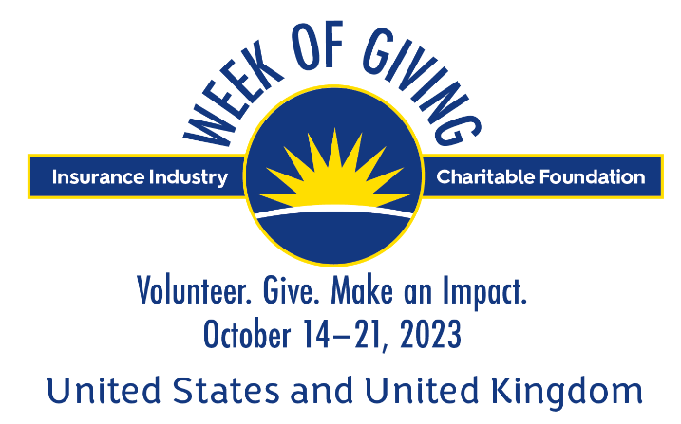

Be a part of something greater! Join [Company] & entire insurance industry as we give back to our communities, Oct 14-21! Visit volunteer.iicf.org to sign up for volunteer projects, order your Week of Giving t-shirts and learn more. #IICFWeekofGiving #IICFimpact

Be a part of something greater! Join thousands of #insurance industry volunteers for #IICFWeekofGiving, Oct 14-21 Visit volunteer.iicf.org to sign up for volunteer projects and learn more.

[Company] employees are giving back through #IICFWeekofGiving! Get involved as #insurancegivesback Sign up at: volunteer.iicf.org

[Company] unites with #insurance industry through volunteerism and giving during #IICFWeekofGiving Visit volunteer.iicf.org to sign up for volunteer projects and learn more. #insurancegivesback #IICFimpact
[Company] is proud to support #IICFWeekofGiving! Join us Oct 14-21 as #insurancegivesback Helping communities and enriching lives, together! volunteer.iicf.org
#insurance industry comes together with #IICFWeekofGiving! Join us & show your community support as #insurancegivesback Volunteer or give at volunteer.iicf.org #IICFimpact

Join thousands of #insurance industry professionals for IICF’s most impactful week of the year! Register or give at: volunteer.iicf.org as we continue nearly 30 years of community support! #IICFWeekofGiving #insurancegivesback #IICFimpact

[Company] volunteers are giving back @ [nonprofit/charity name] today! This is how #insurancegivesback #IICFWeekofGiving volunteer.iicf.org #IICFimpact

[Company] volunteers in action @ [nonprofit/charity name]! #IICFWeekofGiving #insurancegivesback www.iicf.org #IICFimpact
Note: # volunteers or #volunteer hours are great to include too.

On Mondays – incorporate #MotivationMonday into messages above or see new ones below (along with Week of Giving image above or company volunteering photos):

Join thousands of #insurance industry professionals for IICF’s most impactful week of the year! #IICFWeekofGiving Oct 14-21 #MotivationMonday Learn more, sign up & give at: volunteer.iicf.org #IICFimpact

Be a part of something greater! Join thousands of #insurance industry volunteers for #IICFWeekofGiving Oct 14-21 #MotivationMonday Sign up at: volunteer.iicf.org #IICFimpact

On Wednesdays – incorporate #WednesdayWisdom into messages above or see new ones below (along with Week of Giving image above or company volunteering photos):

#WednesdayWisdom 1 in 6 children in the US may experience food insecurity this year. [Company] supports IICF’s fight against hunger through #IICFWeekofGiving Oct 14-21 Sign up to volunteer or give at: volunteer.iicf.org #IICFimpact

#WednesdayWisdom Households with children are significantly more likely to experience food insecurity. You can become an #IICFCampaignChampion by supporting the #IICFChildrensReliefFund by giving or volunteering. Learn more at: volunteer.iicf.org #IICFimpact

[Company] proudly supports IICF in our fight against childhood hunger. #WednesdayWisdom Children who face food insecurity are more likely to experience developmental challenges. You can help by becoming an #IICFCampaignChampion by giving at: volunteer.iicf.org #IICFWeekofGiving #insurancegivesback #IICFimpact

On Thursdays or Fridays – incorporate #TBT or #FBF with photos or info from your participation in last year’s Week of Giving, for example:

#TBT / #FBF [Company] is a proud supporter of #IICFWeekofGiving over the years! Join us Oct 14-21 as #insurancegivesback Visit volunteer.iicf.org to sign up for volunteer projects & learn more. #IICFimpact

#TBT / #FBF of [Company] volunteering [last year] at [nonprofit organization/event name] during #IICFWeekofGiving! Join us Oct 14-21 as #insurancegivesback Visit volunteer.iicf.org to sign up for volunteer projects & learn more. #IICFimpact

#TBT / #FBF [#of [Company] volunteers] proudly contributed to our community [last year]! #IICFWeekofGiving Join us Oct 14-21 as #insurancegivesback Visit volunteer.iicf.org to sign up for volunteer projects, order your Week of Giving t-shirts & learn more. #IICFimpact

Note: Include photos of Week of Giving volunteering in the past for #TBT and #FBF messages.

Status Update Templates

Proud to show my support of the community with #IICFWeekofGiving Oct 14-21 volunteer.iicf.org
#IICFWeekofGiving unites #insurance industry through volunteerism and giving. Oct 14-21 volunteer.iicf.org #insurancegivesback #IICFimpact

#insurance industry unites to show its community support with #IICFWeekofGiving weekofgiving.iicf.org Oct 14-21 #insurancegivesback #IICFimpact

Additional IICF Week of Giving Materials:
To help make your participation with the IICF Week of Giving as convenient as possible, we have many resources available to assist in spreading awareness and excitement, and to help organize your employee support. Please visit weekofgiving.iicf.org to access the following resources:

- IICF Week of Giving Flyer
- IICF Week of Giving Volunteer Team Leader Guide
- IICF Week of Giving FAQs

You can also contact your IICF Division Executive Director or IICF Communications VP, Alisa Breese, at abreese@iicf.org, with questions.

Division Leadership

Kelly Hartweg
Executive Director, Midwest Division
(773) 991-2149 khartweg@iicf.org

Betsy Myatt
Executive Director, Northeast Division
(917) 544-0895 emyatt@iicf.org

Rachel Boulton
Associate Director, Northeast Division
(732) 693-0889
rboulton@iicf.org

Sarah Conway
Executive Director, Southeast Division
(214) 228-2910
sconway@iicf.org

Bree Wiley
Associated Director, Southeast Division
(940) 366-1858
bwiley@iicf.org

Melissa-Anne Duncan
Executive Director, Western Division
(714) 870-1084 maduncan@iicf.org

Wendy Wilder
Executive Director, United Kingdom Division
+44 (0)7469 392 453 wwilder@iicf.org www.iicf.org.uk

Foundation Home Office

Bill Ross
CEO
(562) 697-4002
bross@iicf.org

Alisa Breese
VP, Communications
(949) 412-2143
abreese@iicf.org

Alexis Ziering
Office Manager
(310) 614-9874
aziering@iicf.org

Anna Panoian
CFO
(424) 253-1107
apanoian@iicf.org

Inessa Muradyan
Senior Staff Accountant
(747) 231-9480
inessam@iicf.org

