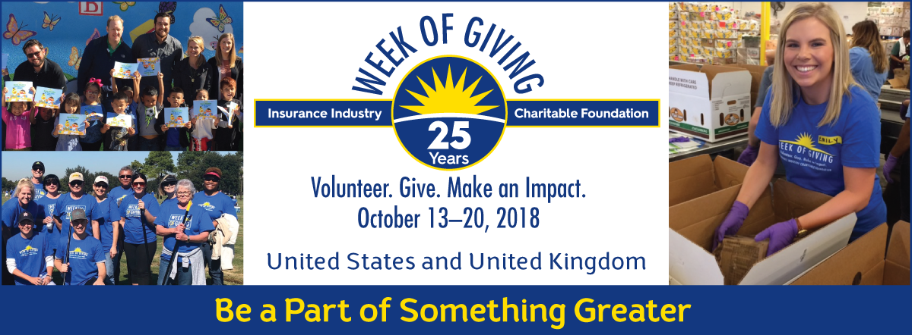

Join [Company Name] as we support the IICF Week of Giving! Together, we are helping communities and enriching lives.

What: [Insert brief description of project.] Example: IICF is collecting new and gently used children’s books.

Where: [Organization]
[Street Address]
[City], [State] [Zip]

When: October [X], 2017 from [X]:00 – [X]:00 [am / pm]

Who: [Insert information on who the project will benefit.] Example: Donations will benefit Words Alive, a San Diego-based nonprofit that focuses on bridging the literacy gap among children from low-income households and at-risk communities by providing shared reading experiences, educating parents and families and providing access to books.

For additional information, please contact [Name], [Title] at [email address] or [phone].
#insurancegivesback #IICWeekofGiving

Benefiting Nonprofit:
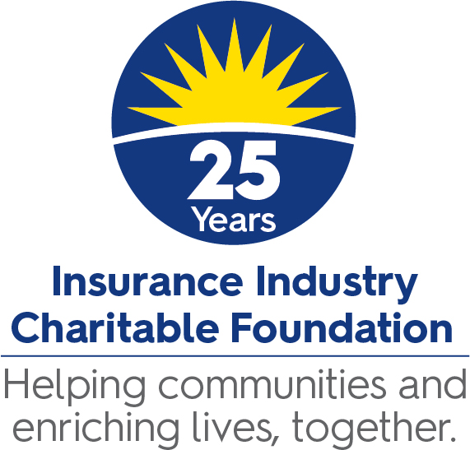
[Insert Nonprofit Logo Here]

